Truth Tables

1. Fill in the truth table for the NOT gate:

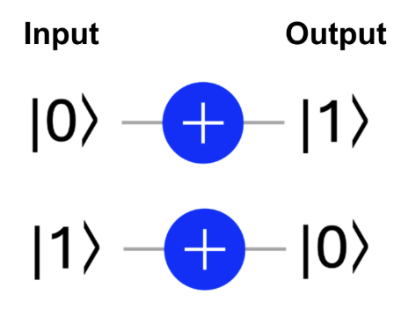

| Input | Output |
| --- | --- |
| 0 |  |
| 1 |  |

1. Fill in the truth table for the SWAP gate:

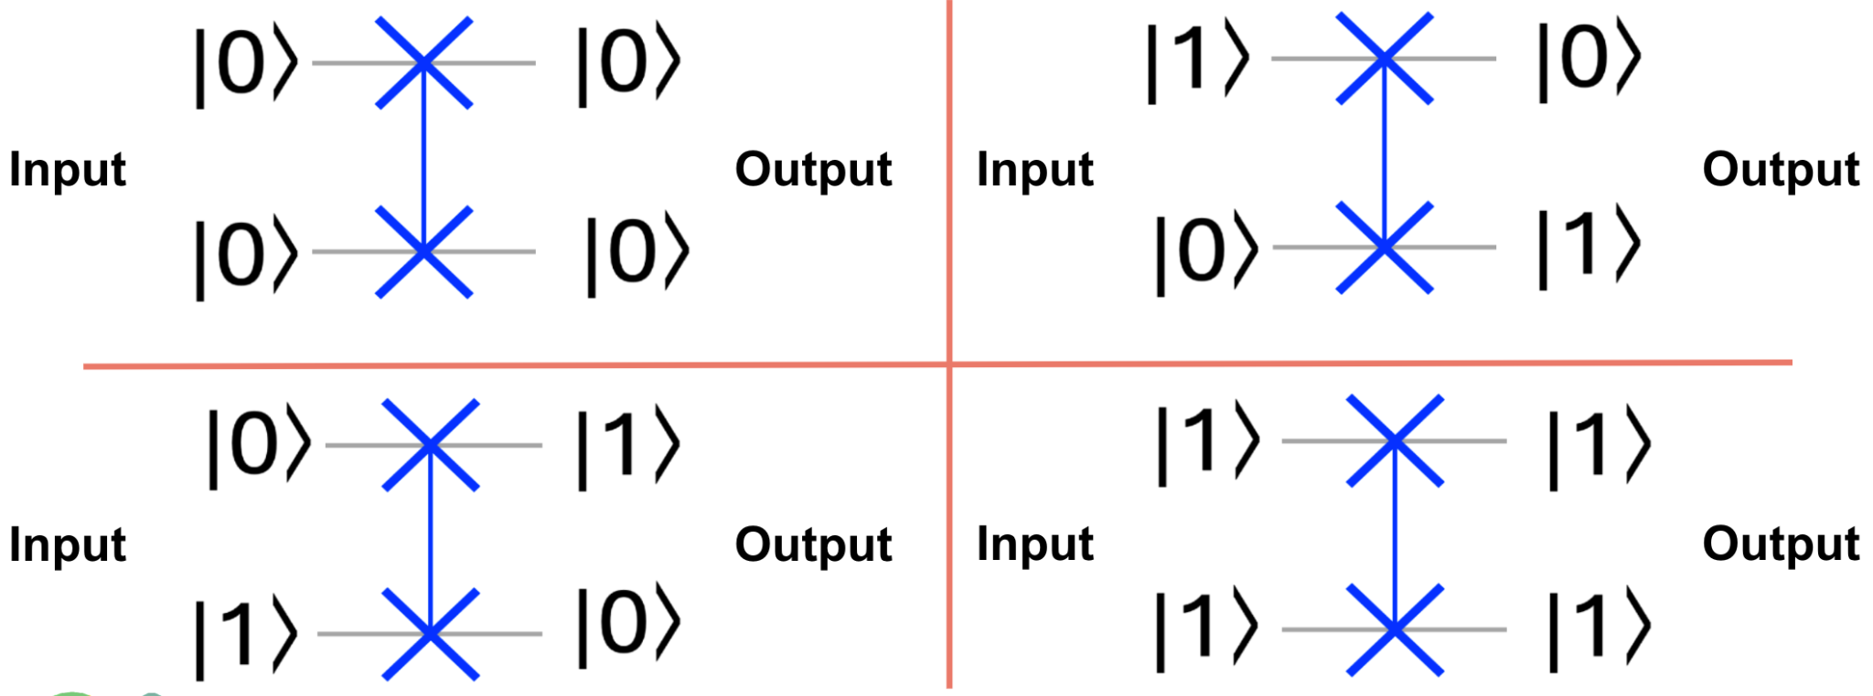

| Input 1 | Input 2 | Output 1 | Output 2 |
| --- | --- | --- | --- |
| 0 | 0 |  |  |
| 0 | 1 |  |  |
| 1 | 0 |  |  |
| 1 | 1 |  |  |

1. Fill in the truth table for the CNOT gate:

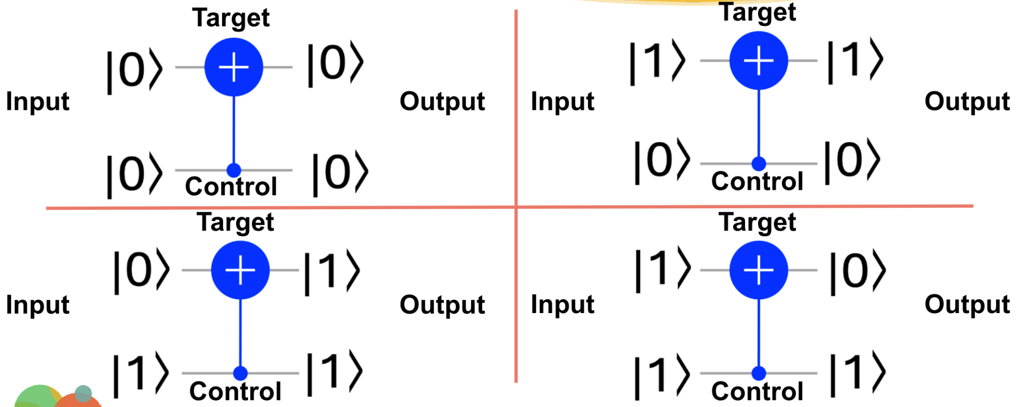

| Control | Target | Output 1 | Output 2 |
| --- | --- | --- | --- |
| 0 | 0 |  |  |
| 0 | 1 |  |  |
| 1 | 0 |  |  |
| 1 | 1 |  |  |

Gates as Matrices

1. What matrix represents the NOT gate?



In = |0> In = |1>

|  |  |
| --- | --- |
|  |  |

1. What matrix represents the CNOT gate?



NOTE: The top bit is always represented by the rightmost number. In the case to the right, the **bottom bit** is the **control** bit, so the **left most number** represents the **control** bit.

In = |00> In = |01> In = |10> In = |11>

|  |  |  |  |
| --- | --- | --- | --- |
|  |  |  |  |
|  |  |  |  |
|  |  |  |  |

1. What matrix represents the SWAP gate?



NOTE: The top bit is always represented by the rightmost number. The **bottom bit** is represented by the **left most number**.

In = |00> In = |01> In = |10> In = |11>

|  |  |  |  |
| --- | --- | --- | --- |
|  |  |  |  |
|  |  |  |  |
|  |  |  |  |